# **Mental Health Under Capitalism**

# **The Introduction**

Did you seriously think you could just suffer back at home from your own mental health problems? But how will Bobby buy his 50th yacht this week? Get back in the factory before I call up daddy government to give you your Neet bucks since apparently the only thing you can is leech of the rich, it’s totally not like the bourgeoisie could retire and live off their wealth for another millennia unless inflation just causes the country to turn into Venezuela.

You know I sure am glad when I look at mental health graphs, it really does make me glad that people just do the ThingTM, No I will not call it by name, because I am writing this on my birthday and needing to interact with other people is already depressing enough. Anyways, back to graphs, does anyone care about them? I swear to God everyone single one I ever saw in my life is just like “Yeah, so like before the internet people were depressed somewhat, now it’s kind of like everyone is dying due to ‘natural causes’, is it just me or is not calling “it” by name just turning into some kind of meta-ironic joke at this point? And whenever it’s clearly a joke it’s only ever funny to me.

No matter what those graphs say it doesn’t really matter in the end just because no one gives a shit and neither does anyone have a reason to care, after all everyone is a mindless drone, one gets depressed, just replace him with another, no one wants a debbie downer in the office after all.

You know it’s totally not like that guy who is dead inside all the time, how a near completely flat voice with barely any facial expression to the point where others wonder if there’s even a soul left inside that vessel housing their mind and the only music they listen is either obscure, ironic or depressing to the point people take one look at what’s playing and their facial expression immediately goes from normal uncaringness to “What in the actual fuck is wrong with this guy” is probably depressed. Holy shit guys, this guy sounds like literally me.

Yes, I am the depressed guy, I sure do wonder how that could’ve ever happened. I sure do, it’s totally not like my life is filled with apathetic inaction and depression while my childhood was traumatic event after traumatic event, in between filled with coping using humor and video games, If I wanted to write an autobiography I would need to release two versions where in one it has like 500 pages literally just about my trauma and then the rest of my life and the second version would just have a summarized version of my trauma. I am not even kidding about 500 pages I am very sure I could stretch it that far with ease.

“How can you be depressed and do something with your life at the same time?” You ask? It’s called having an unending hatred for capitalism and figuring out what to do with my time after getting bored of video games, since the old routine of doing nothing with my life basically, actually I am going to even make an entire flow chart on the second page just for it, so stay hyped for that and hit the like and subscribe button guys, before I continue talking about how depressed everyone is, I would like “BetterHelp” for sponsoring this essay. I am joking, but the amount of people who make a video about mental health and often “self-care”, whatever that’s supposed to even mean anymore. My self-care is listening to YonKaGor and Kennyoung songs while crying.

Fantastic flow-chart:

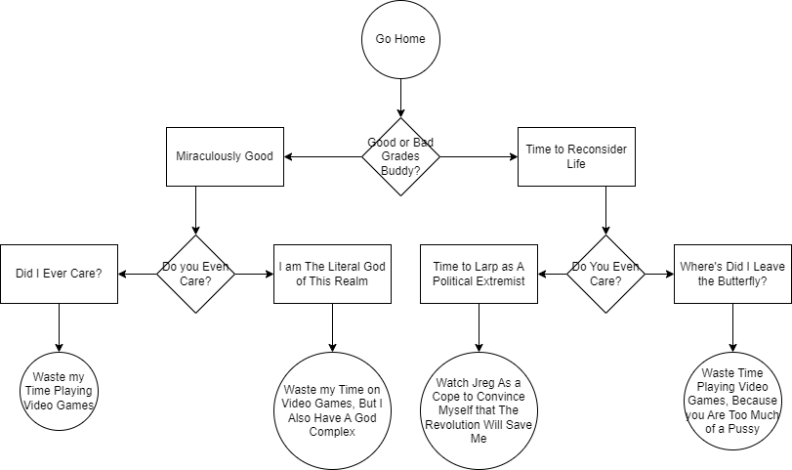

Switch to light mode if you can’t see anything. I am not sorry.

# **But My Yacht!**

I can already tell that Bobby is getting tired by my filthy communist complaining, god forbid workers actually care about their own mental health or children for that matter, I am sixteen (as of the time of writing) and I already was depressed when I was ten. Clearly that system of